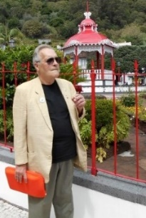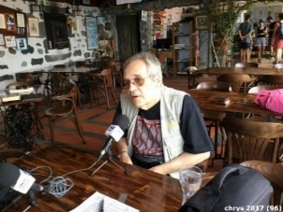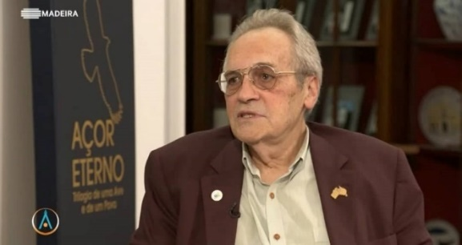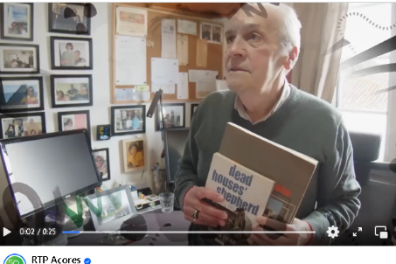
chrys@lusofonias.net - www.lusofonias.net

J. Chrys Chrystello (b. 1949-), an Australian citizen, not only believes in multiculturalism, but is an example of it in a mixed family of Galician, Minho, Brazilian (Carioca), German, paternal, and Christian-New Transmontano, maternal.
From 1967 to the present day, he has always dedicated himself to journalism (radio, TV and the press).
As a poet, he published his first book in 1972, ‘Crónica do Quotidiano Inútil’ (Chronicle of Useless Daily Life).
The Portuguese colonial army took him to his first homeland, Portuguese Timor (1973-75), where he was Editor-in-Chief of the newspaper Voz de Timor, Dili, and became interested in linguistics, confronted with more than 30 dialects, before going to Australia to adopt it as his second homeland. For more than two decades (1976-99) he wrote about the drama of Timor, whose saga the world refused to see.
1976-82 he held executive positions at Companhia de Elede Macau. He was a journalist (Editor, Presenter and Producer at the Macau Broadcasting Corporation - Radio Macau - TDM (RTP) and correspondent for TVB - Hong Kong.
He lived in Perth (1979), settled in Sydney (1983) and Melbourne (1993) and was actively involved in the trade union movement and in the official civil service bodies that defined the country's multicultural policy.
He was a Journalist in the Federal Ministry of Employment, Education and Vocational Training and in the Ministry of Health, Housing and Community Services.
He was an official translator (federal and state) and interpreter for the Ministry of Immigration and the Ministry of Health in New South Wales.
Since 1985 he has publicised the discovery of the arrival of the Portuguese (more than 250 years before Captain Cook) and spread the word about the existence of Aboriginal tribes speaking Portuguese Creole.
For 20 years (1984-2004) he was responsible for exams for Translators and Interpreters (NAATI - National Authority for the Accreditation of Translators & Interpreters).
He was a founder (1989) of AUSIT (Australian Institute for Translators & Interpreters).
He has taught Translation, Linguistics and Multicultural Studies in Sydney at the University of Technology Sydney for NAATI.
He was Portuguese Literature Advisor to the Australia Council (UTS 1999-05).
Mentor for Literature finalists (Association for Computational Linguistics, Information Technology Research Institute) at the University of Brighton, UK (2000-12).
He was a Reviewer (Translation Studies Department) at the University of Helsinki (2005-12) and a Consultant for the REMA Programme at the University of the Azores (2008-12).
In 1999, he published his bilingual MA thesis, ‘East Timor: the secret dossier 1973-1975’, which sold out in three days, and the first volume of the Trilogy on the History of Timor.
In 2000 he published the monograph ‘Crónicas Austrais 1976-96’.
In 2005 he published ‘Cancioneiro Transmontano 2005’ and the second volume of the trilogy ‘East Timor: 1983-92, Historiography of a Reporter’.
After 2005, he translated excerpts by Azorean authors into English in the Bilingual Anthology of Contemporary Azorean Authors.
In 2007 he published the 3rd volume of the Timor History Trilogy, ‘ The Tribal Wars. History repeats itself 1894-2006"
In 2009 he published vol. 1 ‘ChrónicAçores: uma Circum-navegação, De Timor a Macau, Austrália, Brasil, Bragança até aos Açores, (sold out)’ chronicling his travels around the world.
In 2012 he published the complete work of poetry ‘Crónica do Quotidiano Inútil (vol. 1 to 5)’, 40 years of literary life."
In 2015 he released the 4th edition of ‘Crónicas Austrais 1978-1998’ and reissued the 3 volumes of the ‘Trilogia da História de Timor’. He revised and compiled the work of Bishop Ximenes Belo, ‘Father Carlos da Rocha Pereira’, from the Azorean Missionaries in Timor series.
In 2017 he launched the opus magister ‘Bibliografia Geral da Açorianidade’ in 2 vols (1600 pp. with 19411 entries).
In 2017 he adapted and translated ‘The Lost World of East Timor’ by José Ramos-Horta and Patricia Vickers-Rich.
In 2018, she published ‘Fotoemas’, an e-book with photos by Fátima Salcedo and her poems http://www.blurb.com/books/8752953-fotoemas.
In 2018, he revised and compiled vol. 2 of ‘Azorean Missionaries in Timor’ by Bishop Ximenes Belo.
He is Editor of the AICL's Cadernos (de Estudos) Açorianos, an online publication.
In 2019 he was appointed Vice-President for Oceania of the Poets of the World Movement and admitted as a member of Pen International (Azores).
Since 2010, he has chaired the International Association of Lusophone Colloquia, which has organised Lusophone Colloquia since 2001 (39 editions).
In 2022 he celebrated 50 years of literary life with 3 books
Crónica do quotidiano Inútil (complete works of poetry vols 1 to 6);
ChrónicAçores: a circumnavigation, 1949-05, vol. 5, Liames e Epifanias Autobiográficas; and
ChrónicAçores: a circumnavigation, 2005-21, vol. 6, Alumbramento, Crónicas do Éden.
In 2024 he published ‘29 Poemas, 29 anos com a Nini’ in posthumous honour of Helena Chrystello.
In 2025 he launched

ChrónicAçores (vol. 7 – 2021-2023) A Circum-Navegação pós- COVID-19
Diário de um Homem só, UMA VIAGEM INTERIOR , Homenagem a Helena Chrystello, ChrónicAçores vol. 8, 2023-2024
Diário de um homem só II, Manual para viúvos ChrónicAçores vol. 9

